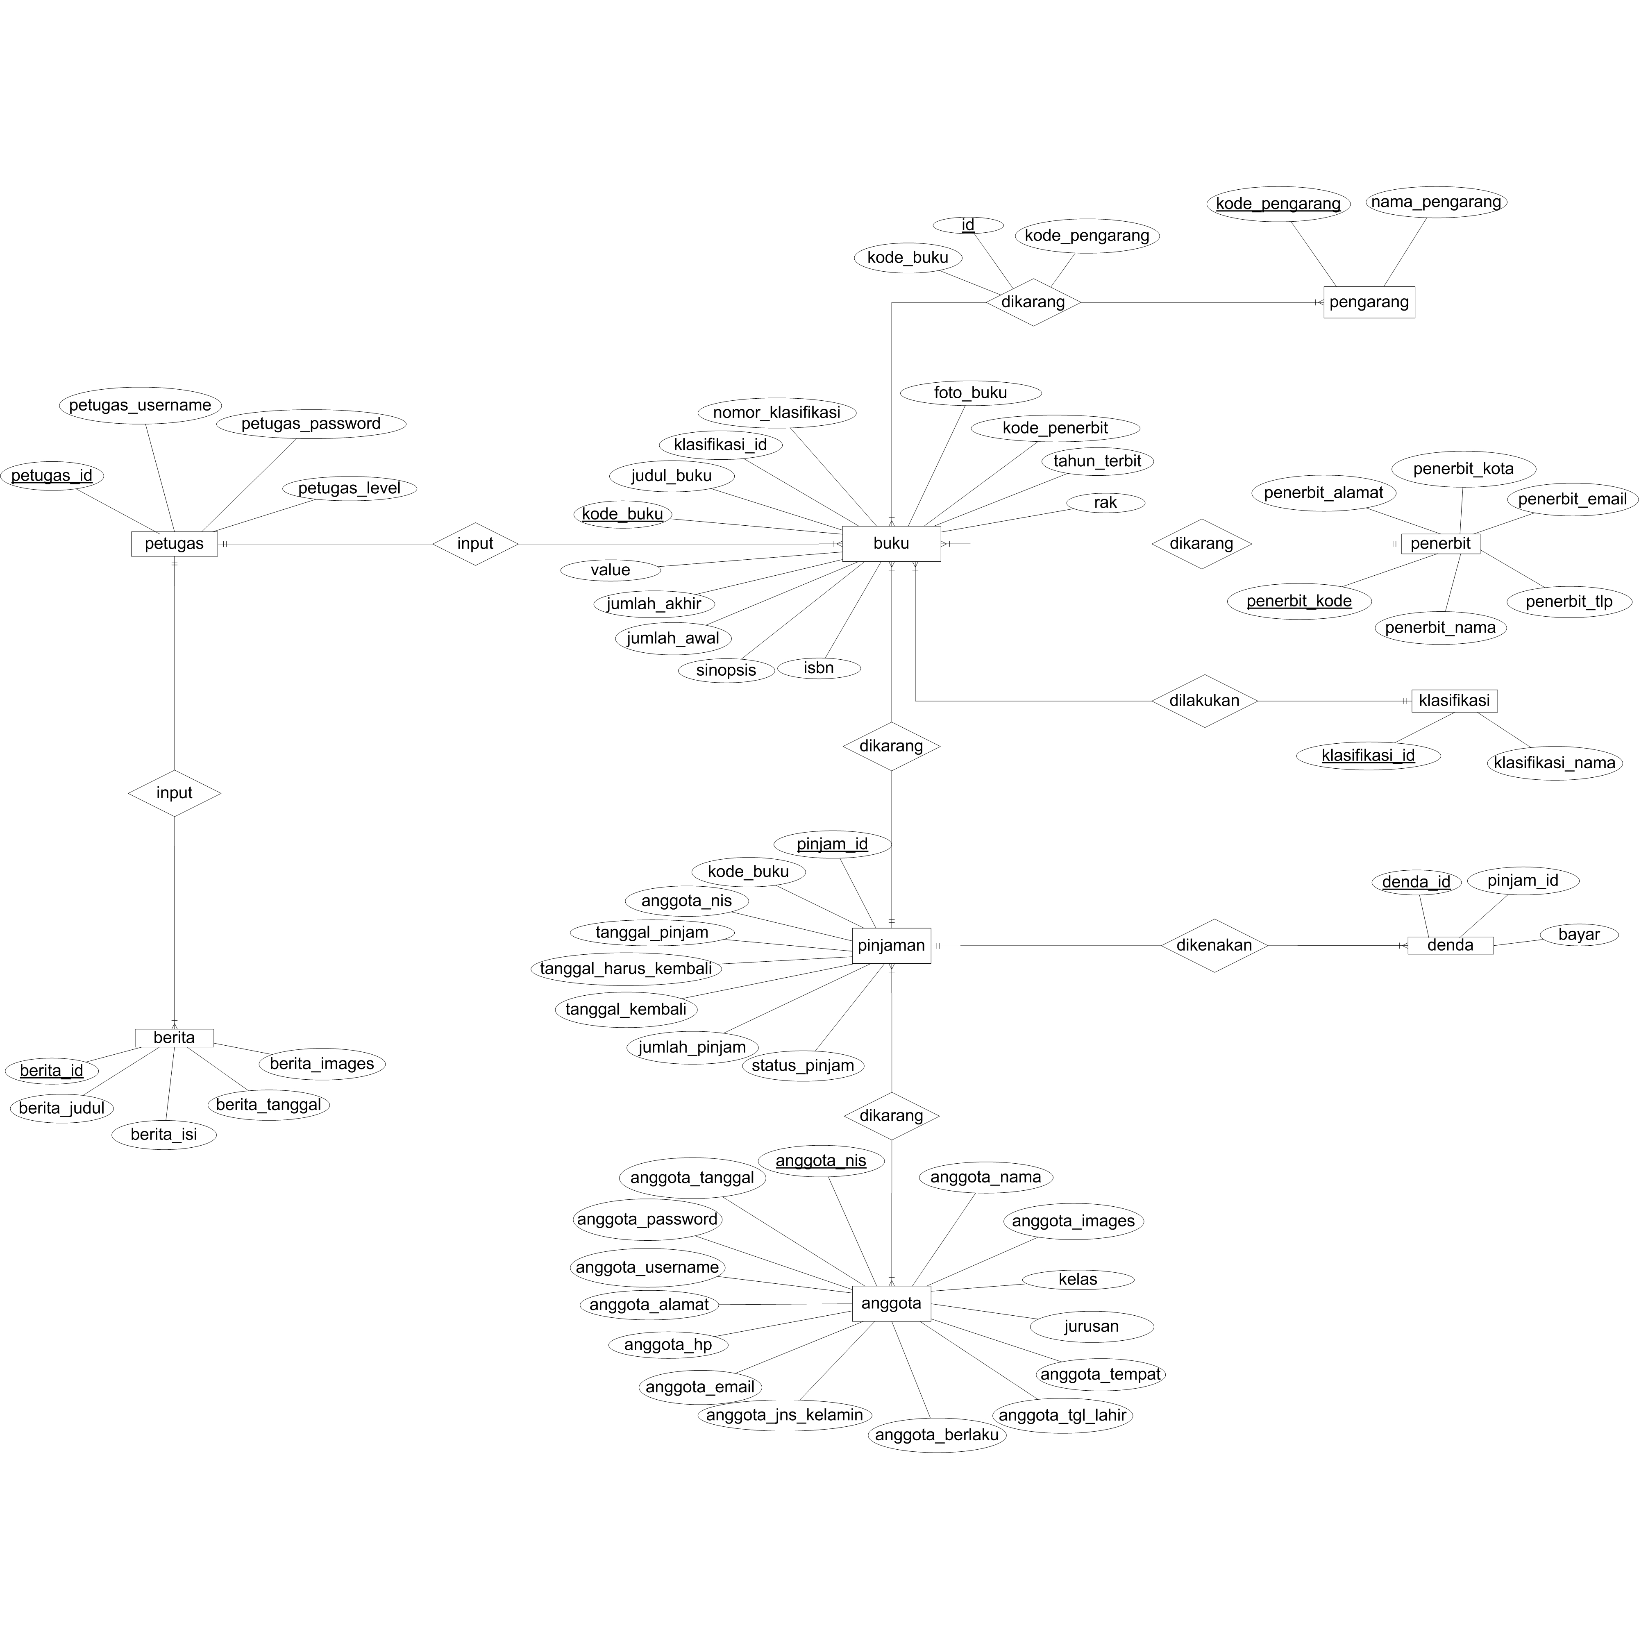

**Gambar 4.16** ERD (*Entity Relationship Diagram)*